Summary Report

Lab3

**PART-A:**

Find all the IP addresses with more than 100 hits.

Change the IpReducer like that:

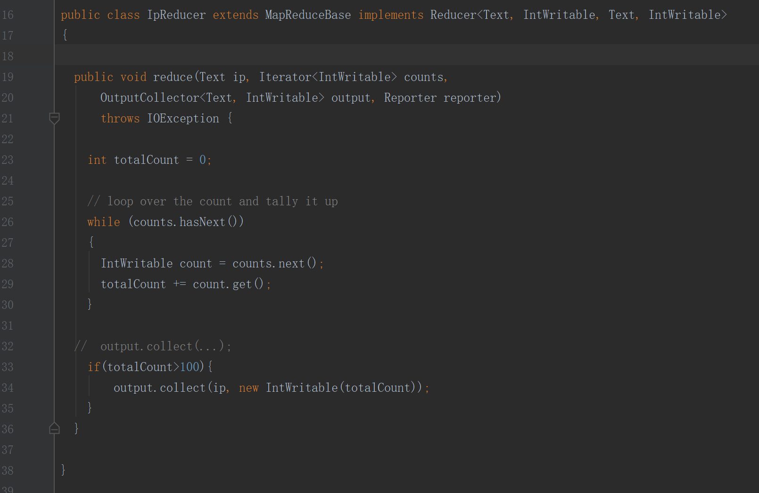

In the IpReducer.java, the hit count of IP address is totalCount, and to find all the IP addresses with more than 100 hits, I need to use a if statement to control the totalCount, let it greater than 100.

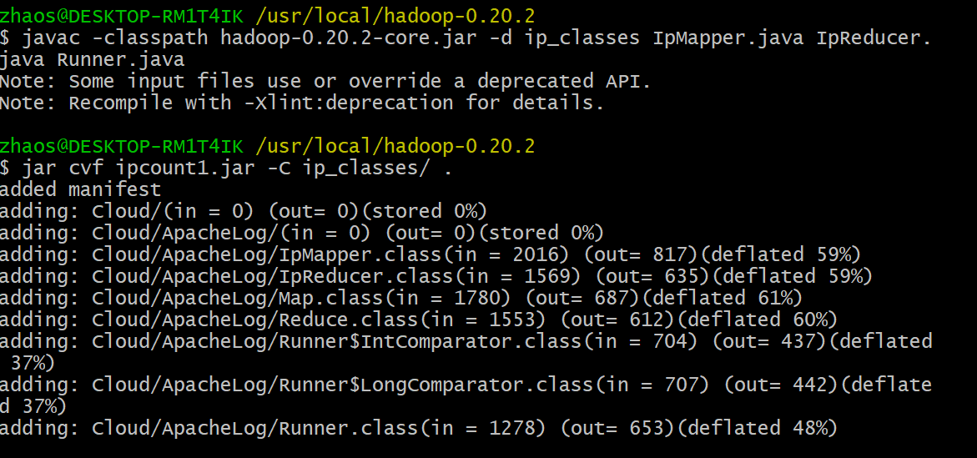

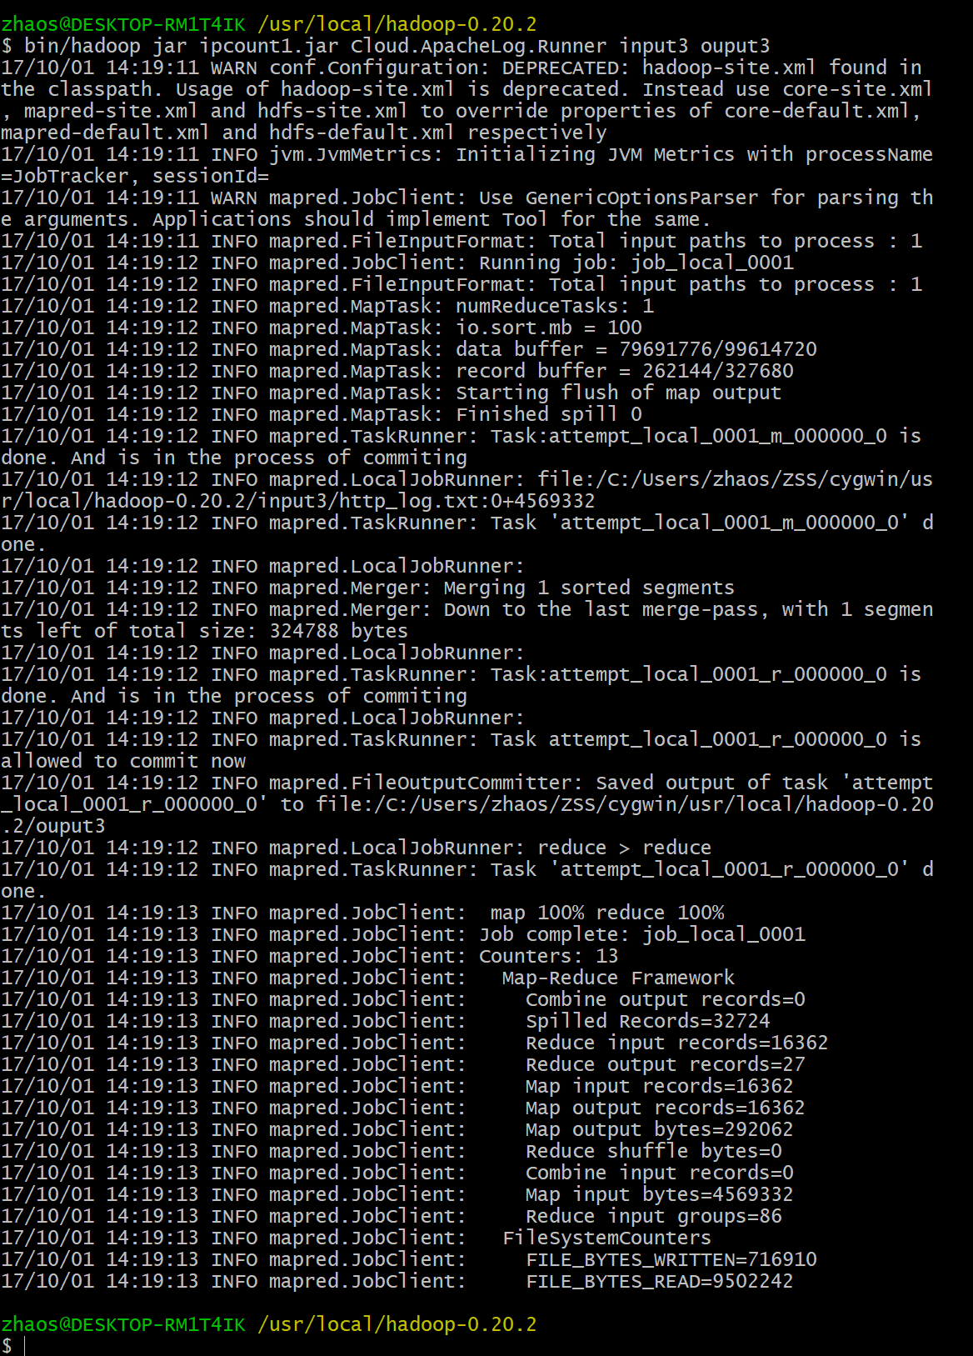

And the first output file:

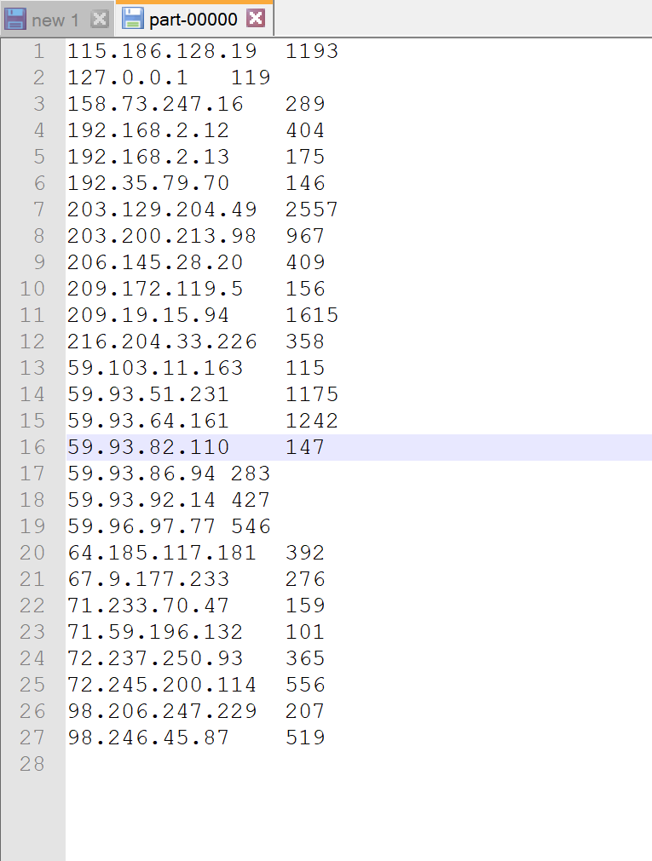

**PART-B:**

Find all the IP addresses with more than 100 hits ***in decreasing order.***

Change the IpReducer.java like that: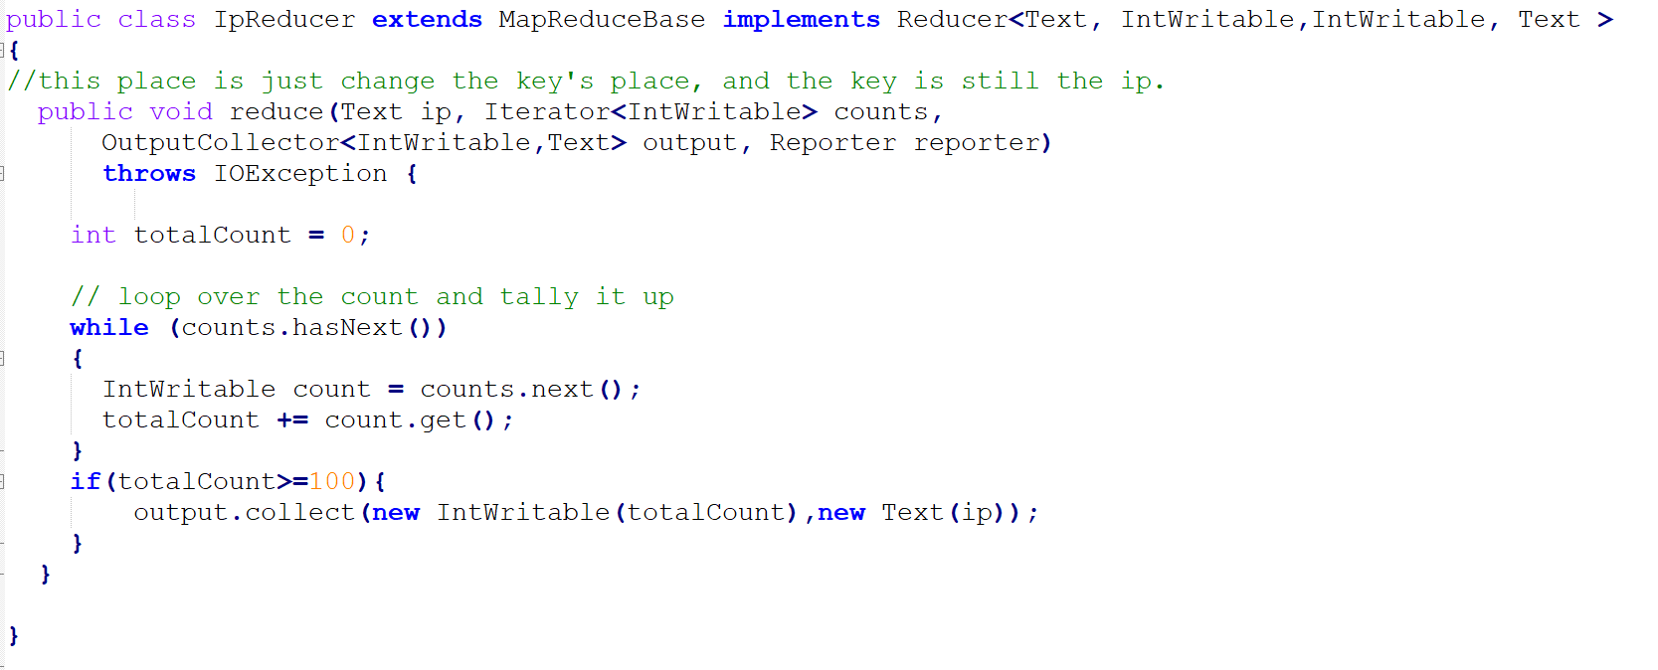

The IpReducer.java is to change the first output’s locations of key and value.

Add a new Map.java for the second input:

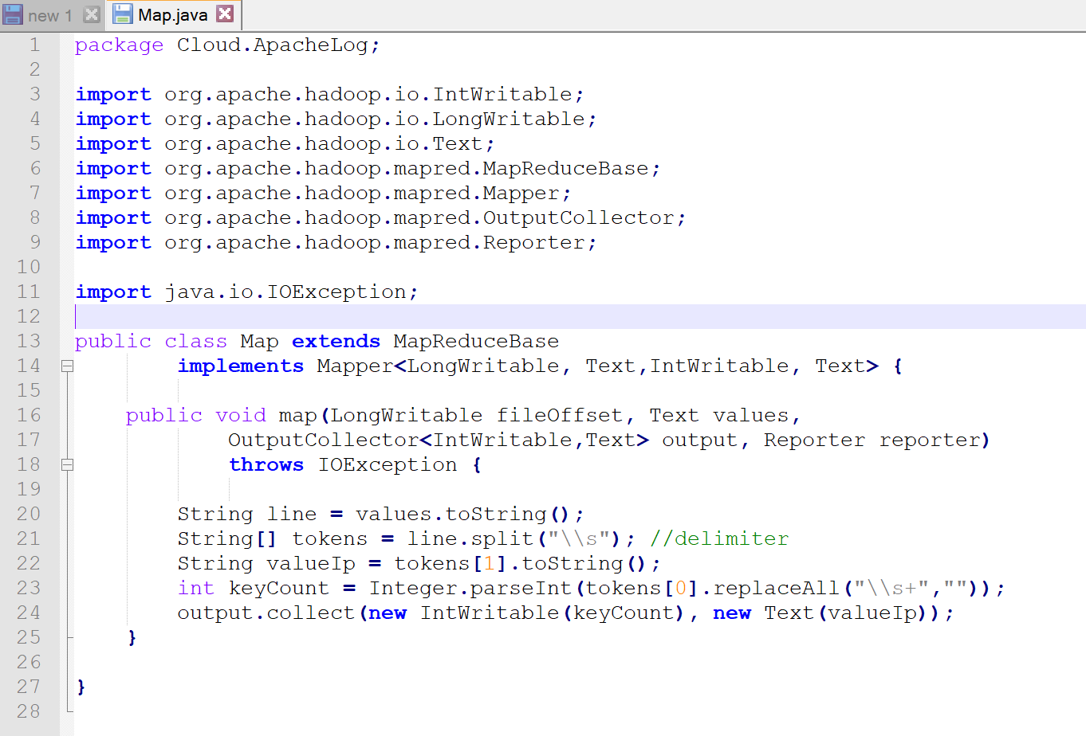

This file is to read the temporary file which the IpReducer.java outputs, and let the count(keyCount) as the key and IP address(valueIp) as the value, and uses the override comparator to sort the count.

Add a new Reduce.java for the final output:

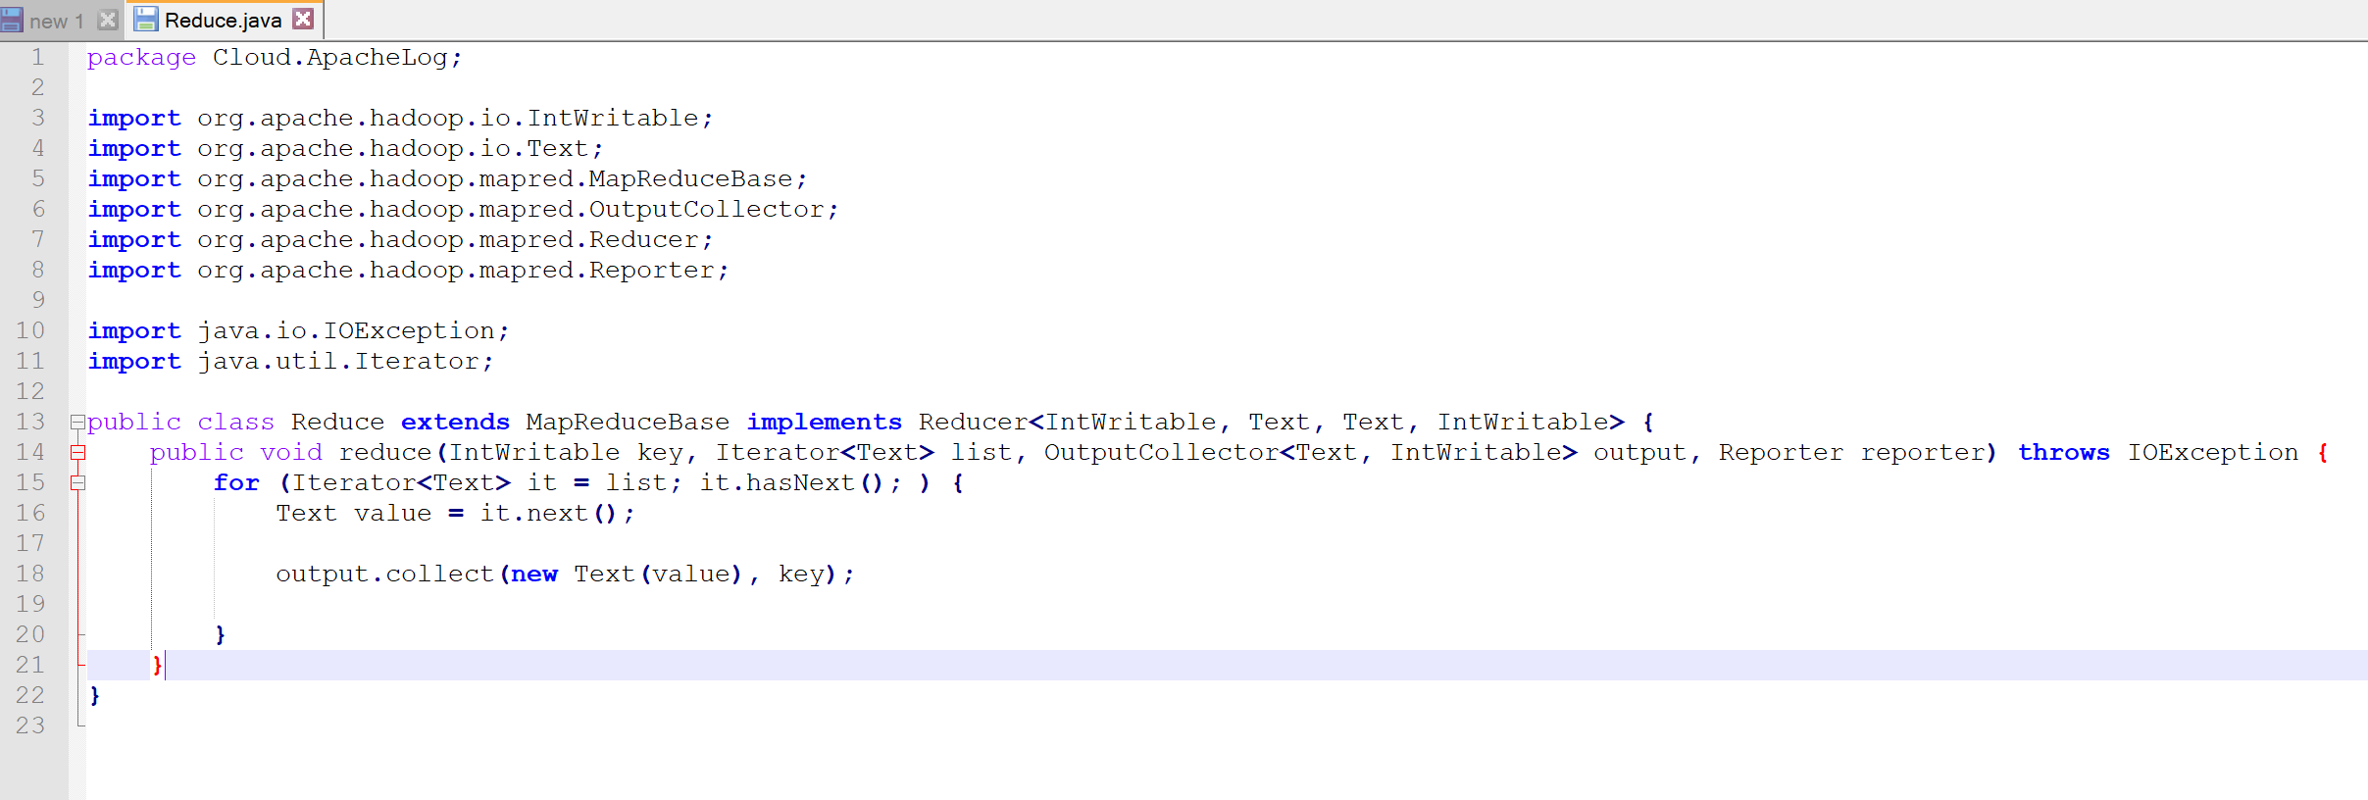

This file is to change the location of the key and value and write the output file.

And the Runner.java changed like that:

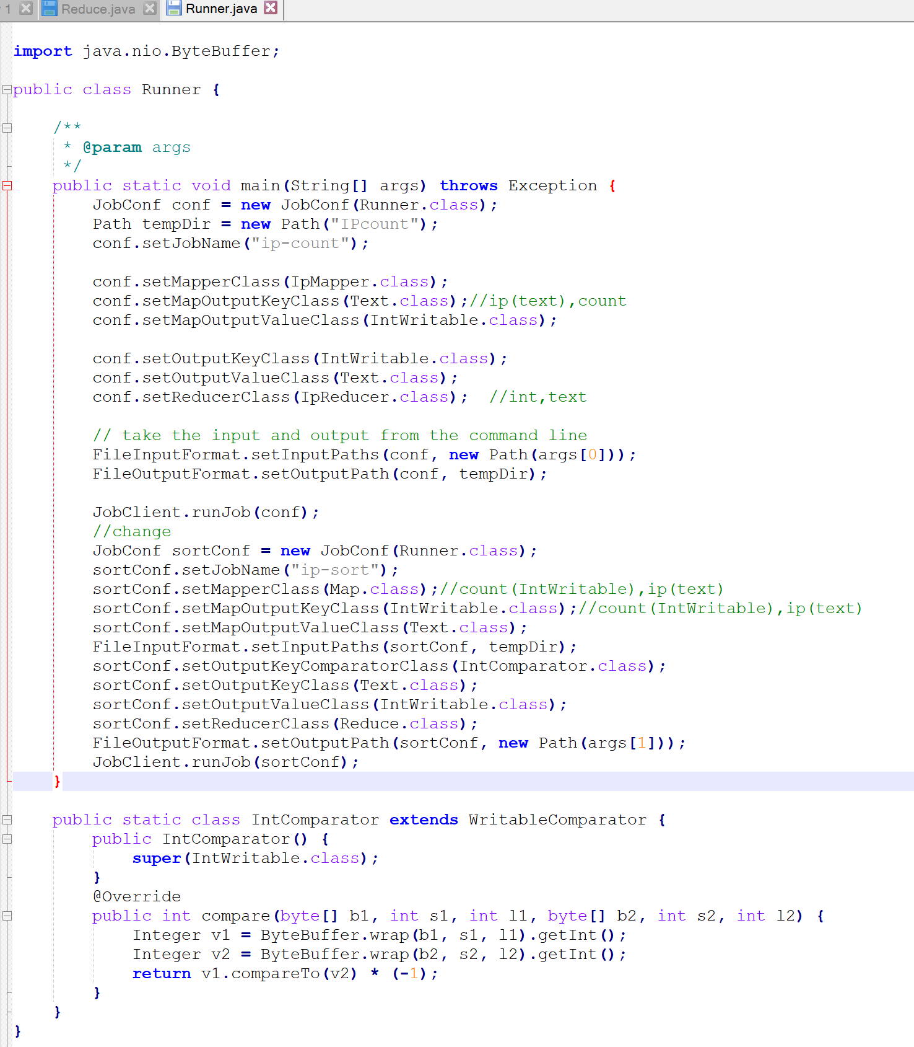

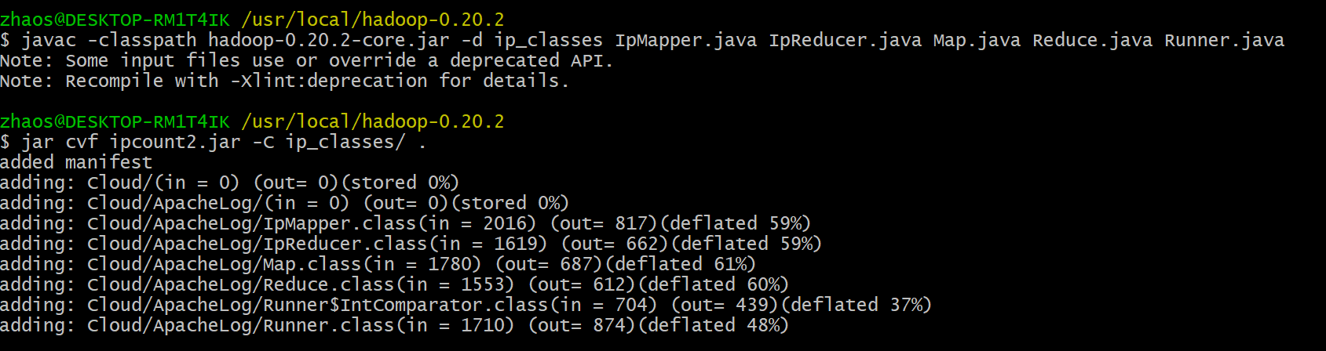

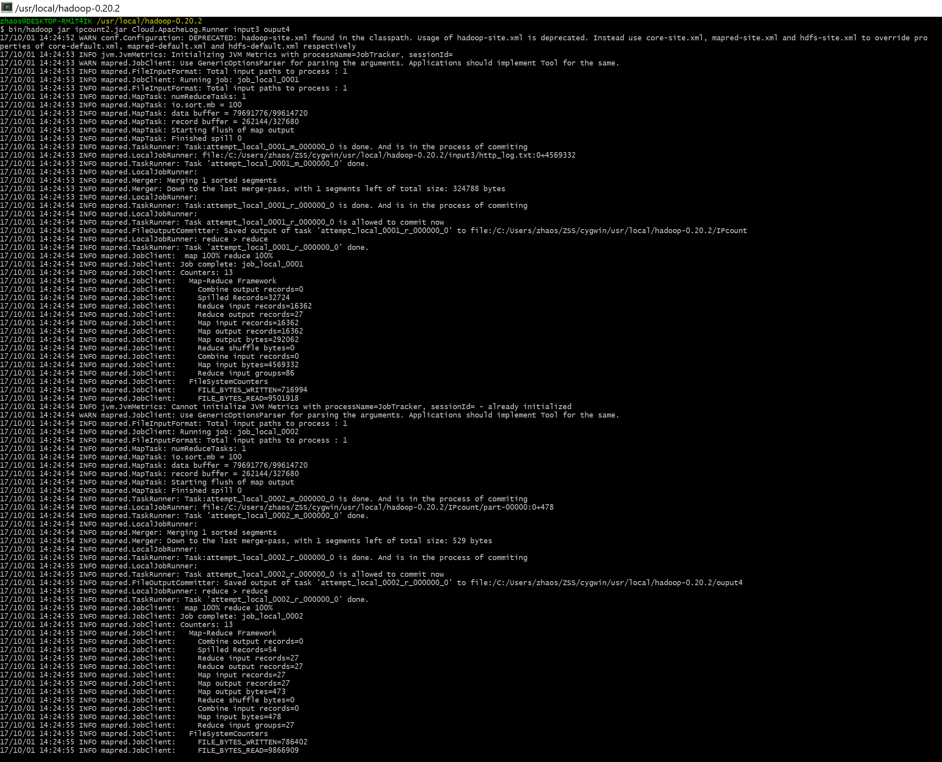

The second output file:

